Resolved: Outer space colonization is a moral imperative.
A foundational guide to the literature, the burden structure, and the argument landscape. Written for students entering their first topic on this resolution, and for the coaches and parents supporting them.

What's In Here
This brief runs in nine parts. If you are brand new to the topic, read Parts 1 through 4 before you touch any evidence. Parts 5 and 6 are the argument maps. Parts 7 through 9 are practical.
Part | Section | What it does
1 | Read This First | Why this topic is unusual and where most debaters go wrong
2 | The Literature | Five camps of authors and what each one actually argues
3 | Definitions | Outer space, colonization, and the phrase that decides rounds
4 | The Burden Structure | What the AFF has to prove and what the NEG does not
5 | Affirmative Landscape | Six positions, with cut cards from the topic files
6 | Negative Landscape | Seven positions, with cut cards from the topic files
7 | How Rounds Play Out | Four common matchups and who is favored in each
8 | Starter Case Skeletons | Bare-bones outlines for a first AFF and first Neg
9 | Research Assignments | What to cut next, and where the good evidence lives

A note on the evidence in this brief
Every card comes from real Podium files.

Part 1. Read This First

THE OVERVIEW
Most Lincoln-Douglas resolutions are policy questions wearing a philosophy costume. But instead of asking whether a country ought to do something, there isn’t a clear plan, an actor, a mechanism, or a set of consequences you can measure. Still, at the national level, you’re sure to find teams who still find a way to treat the topic as a policy one.
The resolution does not ask whether space colonization is good. It does not ask whether it is wise, or likely, or worth funding. It asserts that colonization is a moral imperative, which is a claim about the structure of obligation. An imperative is something you are required to do, so failing to do it is not a missed opportunity, it is a moral failure. That is a much heavier claim than “this would be a good idea,” and almost none of the literature actually defends it.
This distinguishes the topic from the former topic on space appropriation, though some argument overlap can be expected and the 2022 JanFeb wiki might be a good place to start for additional evidence.

The gap for you to notice
The evidence base is deep. Philosophers have been fighting about this in journals like Futures and Space Policy for two decades, and the fight is unusually well-suited because it is a fight about values rather than about appropriations.
But almost all of that literature (Bostrom, Deudney, Torres, Kovic, Szocik, and the rest) answer whether space colonization would be beneficial or harmful. Very few of them are arguing about whether it is obligatory.

That matters:
Proving that space colonization would be extremely good is not the same as proving we are required to do it. The AFF has to close that gap. The NEG wins a lot of rounds by refusing to let them.
A debater reads Bostrom saying delayed colonization costs 10 to the 46th potential lives per century. Devastating. Then the NEG stands up and says: granted, that is a staggering good, and staggering goods are exactly the category of thing moral philosophy treats as admirable but optional. Donating a kidney to a stranger saves a life. Nobody thinks you are a criminal for keeping both kidneys. The AFF now has to explain why this particular staggering good crosses from praiseworthy into required, and if they have not prepared that explanation, the round is over.

Why this is a good topic for learning
Both sides have a story you can say in one sentence, which is rare and valuable when you are starting out.
Affirmative: Humanity keeps every person it has ever had on one fragile planet. That is a single point of failure, and we have a duty to fix it.
Negative: We cannot do it, we cannot afford it, and the promise of a second planet is an excuse to stop taking care of the one we have.
Both are intuitive and defensible. Both connect to real published scholarship rather than debate-camp inventions. And the philosophical machinery underneath, obligation versus permission, present duties versus duties to future people, is the machinery you will use on every topic after this one. That is the pedagogical value here, and it is why I would rather a novice go deep on this resolution than memorize twelve extinction scenarios.

How I would coach this topic in week one
Spend the first week on definitions and the burden structure and nothing else. Do not cut a single impact card. Have students write out the difference between obligatory, permissible, supererogatory, and prohibitory, and then place ten different actions into those four boxes. Then, and only then, hand them the evidence. Students who understand the deontic categories will use the evidence correctly. Students who get the evidence first will read it at the wrong question for two months.

Part 2. The Literature: A Map
The topic literature sorts into five camps. Knowing which camp an author belongs to tells you what they will and will not concede, which matters enormously when you are answering evidence in a round.

Camp 1. Longtermists and existential-risk scholars
The intellectual center of gravity for the Affirmative. Key names: Nick Bostrom (“Astronomical Waste,” 2003), Toby Ord (The Precipice, 2020), Milan Cirkovic, Timothy Reuter at the World Economic Forum, and Al Globus. The moral weight of the far future is so large that reducing extinction risk dominates every other consideration, and that a single-planet species cannot reduce that risk past a certain floor.
Watch for this: Bostrom's own conclusion is not “colonize immediately.” His “maxipok” rule says maximize the probability of an acceptable outcome, which he thinks means reducing risk first so that settlement can happen safely. A prepared NEG will read Bostrom against a rushing AFF.

Camp 2. Space advocates and frontier theorists
Older and more romantic than the longtermists. Gerard K. O'Neill (The High Frontier, 1976), Robert Zubrin (The Case for Mars), and in the public sphere Elon Musk and Jeff Bezos. Zubrin's argument is explicitly not the lifeboat argument. He argues that an open frontier keeps a civilization innovative and free, and that closing the frontier produces stagnation.
Also here: Michael Mautner's “biotic ethics,” which holds that organic life is uniquely valuable in a sterile universe and that we have a duty to propagate it. Mautner is one of the very few authors who uses the words “moral imperative” about this topic and means them literally. He is worth finding for the AFF.

Camp 3. Technical skeptics
Authors who are not making a moral argument at all. They are arguing that the thing cannot be done. Konrad Szocik, Andrey Levchenko and colleagues, Adam Morton (Should We Colonize Other Planets?), and science journalist Sarah Scoles. Radiation, partial gravity, reproduction, closed-loop life support, perchlorate soil, the absence of any working self-sustaining biosphere anywhere. Add the NASA-sponsored Jakosky and Edwards study finding that Mars does not have enough accessible carbon dioxide to terraform with present technology.
Why this camp matters more here than usual: On a policy topic, feasibility is a solvency argument. On a moral-imperative topic, it is closer to a framework argument, because most ethicists accept some version of “ought implies can.” If it cannot be done, it cannot be required.

Camp 4. Political and geopolitical critics
The most sophisticated Negative ground. Daniel Deudney's Dark Skies (Oxford, 2020) is the single most important book on the NEG side, and its argument is an inversion rather than a denial: space expansion increases existential risk by militarizing the ultimate high ground and by handing humanity asteroid-deflection technology that doubles as a planetary weapon. Martin Rees calls the Planet B idea a dangerous delusion. Kim Stanley Robinson argues the economics are fantasy. Charles Cockell argues that sealed habitats are structurally tyranny-prone because whoever controls the oxygen controls everything.

Camp 5. Critical theory
The camp that attacks the resolution's framing rather than its cost-benefit math. Emily Ray and Sean Parson on caelum nullius and the colonial logic of property rights. Deondre Smiles on the settler logics of outer space. Natalie Trevino on the coloniality of space exploration. Peter Dickens on space as capitalism's spatial fix.
The link is the word itself. A resolution that said colonization is permissible would be much harder to kritik. A resolution that says it is a universal duty is, on this reading, exactly how a particular order universalizes itself.

The three authors who literally defend the resolution
If you are the AFF and you want evidence that says what the resolution says, look at Brian Patrick Green (“An obligation to colonize outer space,” Futures, 2019), Gonzalo Munevar in the same 2019 Futures special issue, and Michael Mautner on panbiotic ethics. Green's argument runs through Hans Jonas: the existence of humankind is a precondition for morality itself, so the first principle of morality is that humankind must exist.

Part 3. Definitions

Resolved: Outer space colonization is a moral imperative.

“Outer space”
Less contested than you would expect, and rarely round-deciding, but you should know it. There is no universally agreed legal boundary where airspace ends and space begins. The Federation Aeronautique Internationale uses the Karman line at 100 km. NASA and the FAA use 80 km. The 1967 Outer Space Treaty, the foundational instrument of space law, does not define a boundary at all.
What the Outer Space Treaty does say matters more. Article I declares that exploration and use shall be carried out for the benefit of all countries and shall be the province of all mankind. Article II forbids national appropriation by claim of sovereignty, by means of use or occupation, or by any other means. Both articles get used by both sides, which is a sign you should read them yourself rather than trusting a card.
You’ll find plenty of T cards defining this on the previous HS LD topic.

“Colonization”
This is where the topic gets interesting, because the drafters chose a word the field has been actively trying to retire.
Narrow sense: settlement plus exploitation of territory plus a territorial claim. This is roughly O'Neill's usage in the 1970s.
The community's preferred replacement: “settlement.” Bill Nye put it plainly at the 2019 International Astronautical Congress, saying the planetary community discourages the verb “colonize” and prefers “settle,” because colonizing has understandably gotten a bad reputation.
But “settler” is not clean either. The people who displaced Native Americans were called settlers. Neither word escapes the history.
The distinction that actually matters: a research station is not a colony. The ISS is not a colony. A Moon base is not automatically a colony. Colonization implies permanent, self-sustaining human presence with the intent to live and reproduce there. That word self-sustaining is doing enormous load-bearing work, and the NEG should make the AFF carry it.

“Moral imperative”
This bakes debates about philosophy into the topic.

Kant's distinction
A hypothetical imperative is conditional: if you want end X, you ought to do Y. A categorical imperative commands unconditionally, regardless of what you happen to want. Kant's first formulation: act only in accordance with that maxim through which you can at the same time will that it become a universal law.
Notice that a lot of Affirmative evidence is structured as a hypothetical imperative. If you want humanity to survive, you ought to colonize space. That is a conditional, and a NEG can press on the antecedent.

The four deontic categories
Moral philosophy standardly sorts actions into four boxes. Every student on this topic should be able to define all four cold.
Category | Meaning | Example
Obligatory | Required. You fail morally if you do not do it. | Keeping a promise; rescuing a drowning child at no risk to yourself
Permissible | Allowed but optional. Morally neutral. | Choosing chocolate over vanilla
Forbidden | Prohibited. You fail morally if you do it. | Torturing for entertainment
Supererogatory | Good beyond the call of duty. Praiseworthy but not required. | Donating a kidney to a stranger; running into a burning building

The Stanford Encyclopedia of Philosophy's entry on supererogation notes that it would be absurd to force a person to perform a supererogatory act even if that act had extremely beneficial consequences. That clause is the Negative's best sentence on this entire topic. Read it in Part 6.

Imperative for whom?
The resolution names no agent. This is not a technicality. Obligations attach to agents, and different agents produce different analyses.
If the duty-bearer is humanity as a collective, you need an account of how a collective can bear a duty and how it discharges one.
If it is governments, you have to explain why an obligation survives democratic majorities that do not want to fund it.
If it is private companies, you have a category problem: firms have fiduciary duties to shareholders, not moral imperatives. A corporation is permitted to colonize space if it is profitable. It is not required to.
The last point is sharper than it looks, because in practice the private sector now leads. SpaceX was founded in 2002 explicitly to enable the colonization of Mars, and it conducts roughly half of all global orbital launches. The single most important actor in human spaceflight is a company built around one person's ideology. Whether that entity can bear a moral imperative at all is a live question.

Part 4. The Burden Structure
 | Affirmative | Negative
Must prove | That colonization is morally required, not merely good, admirable, or permitted | Any one of: not required, not possible, not net-beneficial, or wrong in kind
Timeframe | Stronger on long horizons. Centuries and millennia are friendly ground. | Stronger on the present. Prematurity, cost, and current technology are friendly ground.
Framework need | High. Needs a theory that generates duties from consequences or from a precondition argument. | Lower. Can win on the Aff's own framework by denying the obligation step.
Presumption | Against, in most judges' hands, because the resolution makes the stronger claim | Generally with, though never assume this.

The asymmetry, stated plainly
The Negative does not have to prove that space colonization is bad. That is the most common misunderstanding on this topic and it costs novices rounds in both directions.
AFF error: spending the 1AR answering “space colonization is harmful” arguments the NEG never made, while the actual NEG argument (it is optional) goes cold. I already know this is going to be a big issue.
NEG error: feeling obligated to impact-turn the case when a cleaner path was available. If you can win that the good is real but optional, you do not need Deudney at all.

Ought implies can
A principle with wide acceptance across ethical traditions: you cannot be obligated to do something you are incapable of doing. On a policy topic this would be a solvency press. Here it functions as a framework press, and it is why the technical-feasibility literature punches above its weight.
The Affirmative response worth preparing: “can” is not limited to “can right now.” We can be obligated to begin a project we cannot finish, in the same way a generation can be obligated to start building a cathedral. The AFF should reframe the imperative as a duty to pursue rather than a duty to complete.

Cross-examination questions that decide rounds
For the AFF to ask the Neg: “Do you concede space colonization would be good? If so, what specifically converts an enormous good into an optional one?”
For the NEG to ask the Aff: “Who bears this obligation? What if it’s refused?”

Part 5. The Affirmative Landscape
Six positions, ordered from most to least common. The first two will be the backbone of most Affirmative cases. The third is the one that most directly answers the resolution as written, and it is underused.

5.1 Existential risk and the lifeboat
Earth faces a set of low-probability, high-consequence catastrophes that share one feature: they are correlated. A large asteroid, a supervolcano, a nuclear exchange, an engineered pathogen. Because every human being is on one planet, any one of these can take all of us at once. A second self-sufficient population breaks that correlation.
CARD 1 | AFF, EXISTENTIAL RISK
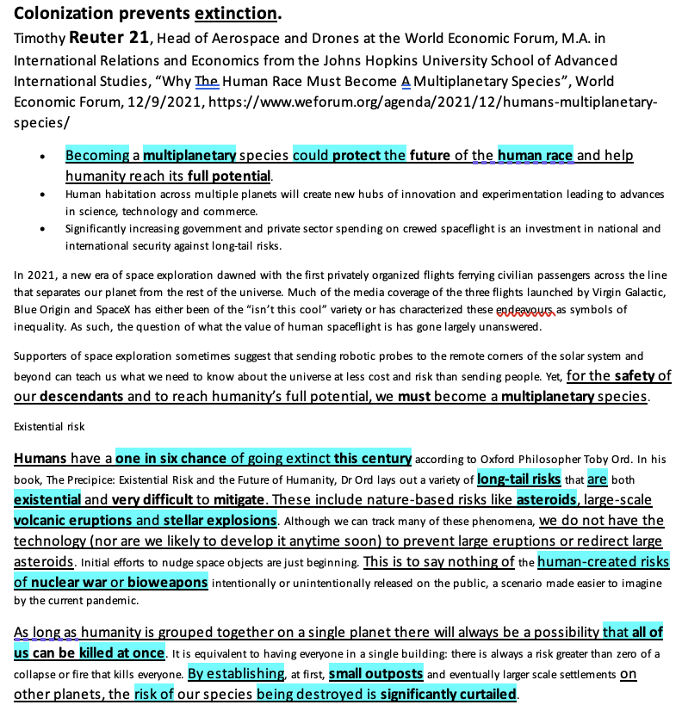
Note what this card gives you and what it does not. It gives you the single-point-of-failure logic in a memorable image, and it gives you Ord's one-in-six figure through a credible institutional source. It does not give you the obligation step. Reuter's own conclusion is that increased spending is a good investment, which is a prudential claim, not a moral one. You have to supply the bridge.

The adaptation answer, and the answer to it
The Negative's first move here is that we can do the same risk reduction on Earth more cheaply. Bunkers, seed vaults, pandemic preparedness, asteroid tracking. The Affirmative's best card on this is Cirkovic, and the last sentence is the one to read.
CARD 2 | AFF, ANSWERS EARTH-BASED ALTERNATIVES
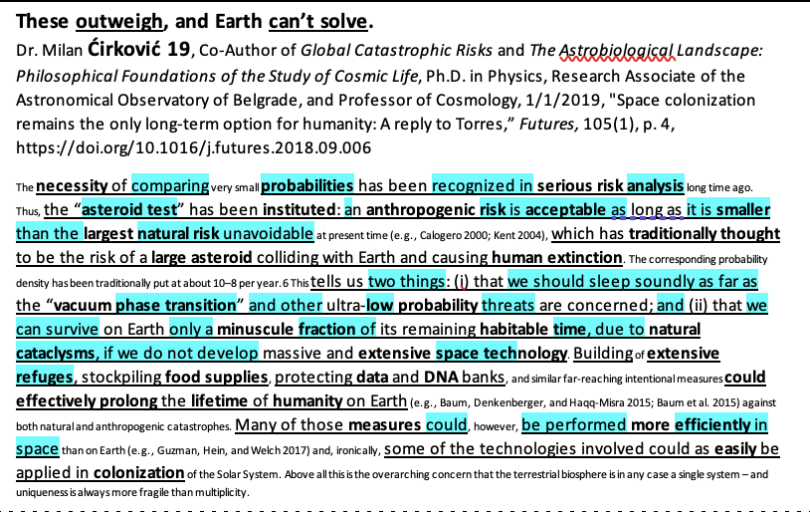
If you read the article, it mentions that “uniqueness is always more fragile than multiplicity.” That reframes the debate from a comparison of interventions to a comparison of structures. A refuge on Earth is still on Earth. It shares the biosphere it is meant to survive.

5.2 Astronomical waste and the value of the future
The most aggressive version of the Affirmative, and the one that most directly generates the size of impact that can support a claim of obligation. Bostrom's argument is that the potential value of a colonized future is so large that delay itself carries a moral cost measured in unlived worthwhile lives.
CARD 3 | AFF, LONGTERMISM
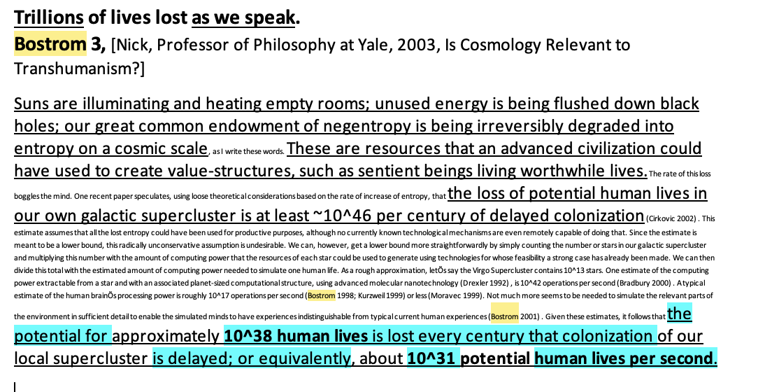
Three coaching notes. First, do not read this card as though the number is the argument. The number is meaningless without the premise that future people count fully and that value aggregates linearly. State the premise. Second, be ready for the fact that this card is a double-edged sword, because it is the exact target of the suffering-risk literature in Part 6. Third, Bostrom has been called out for saying some problematic things, which may prove annoying to have to answer - other people in the literature make similar claims.

5.3 The precondition argument (the cleanest route to “imperative”)
If you only take one strategic recommendation from this brief, take this one. The argument runs through Hans Jonas and is developed for space specifically by Brian Patrick Green: the existence of humankind is a precondition for morality itself. There are no duties, no values, and no moral reasoning in a universe without moral agents. Therefore the first principle of any moral system has to be that humankind continues to exist, and every other moral value is downstream of that.
Why this matters structurally: it does not merely assert a large good. It argues that the survival of moral agency is a condition of the possibility of obligation as such, which means it can generate a duty without relying on aggregative utilitarianism. That lets an Affirmative answer a deontological Negative on that Negative's own terms, and it insulates you from the supererogation press, because supererogation is a category that only exists inside a functioning moral framework.
Where to find it: Green, “An obligation to colonize outer space,” Futures 110 (2019). Related: the same 2019 Futures special issue includes Munevar making a parallel case. This is a small literature and you can read all of it in a weekend.

5.4 Biotic ethics: the duty is owed to life, not to us
A distinct framework that avoids the anthropocentrism the kritiks target. Michael Mautner's biotic and panbiotic ethics hold that organic gene-protein life is uniquely valuable in an otherwise sterile universe, that life shares a drive to self-propagate, and that human beings therefore have a moral imperative to secure and expand the family of organic life in the universe.
Strength: it is one of the only frameworks in the literature that uses the resolution's own phrase and means it. It also decenters humanity, which blunts some critical links.
Weakness: the move from “life self-propagates” to “we ought to maximize life” is a textbook is-ought problem. Have an answer ready.
Collision: it runs directly into the suffering-risk argument. Maximizing biomass may maximize suffering, since wild animal lives are dominated by predation, disease, and starvation.

5.5 Frontier, flourishing, and stagnation
Zubrin's argument, and worth knowing even though it is the weakest fit for the word “imperative.” The claim is that an open frontier keeps a civilization dynamic, innovative, and free, and that a closed one produces stagnation. Zubrin explicitly sets the lifeboat argument aside; his point is expansion of creative power, not insurance.
Honest assessment: this argues for vitality rather than duty, which places it closer to the supererogatory than the obligatory. It also walks directly into the settler-colonialism kritik, since “frontier” is the precise word that literature targets. Use it as supporting offense, not as your framework.

5.6 Turning the Negative's own authors
A high-value move on this topic, because two of the most-read Negative authors concede more than debaters realize. Kovic writes the definitive article on the risks of space colonization, and his conclusion goes Affirmative.
CARD 4 | AFF, INDICTS THE RISK LITERATURE
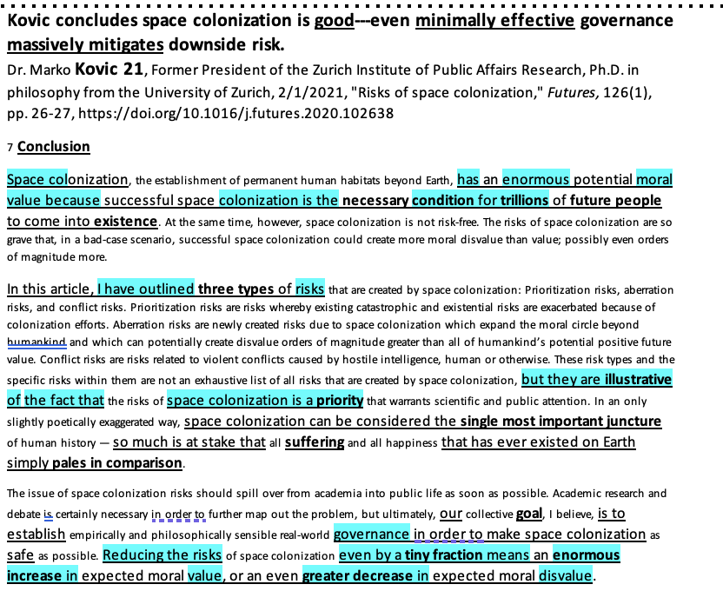
What this card does in a round: when a Negative reads Kovic as an impact card about aberration risks or conflict risks, you extend the conclusion. Kovic's own recommendation is governance, not abstention. Reducing the risks even fractionally produces an enormous increase in expected moral value, which is an argument for doing it carefully rather than not doing it.

5.7 Framework menu for the Affirmative
Framework | How it generates the obligation | Vulnerable to
Act utilitarianism / maximizing expected wellbeing | Largest expected value wins; scale of the future dominates | Supererogation press; demandingness objection; s-risk turn
Jonas / precondition ethics (Green) | Existence of moral agents is prior to all other duties | Ought-implies-can; “Earth survival also satisfies this”
Biotic ethics (Mautner) | Duty owed to life itself, not to humans | Is-ought gap; s-risk turn
Contractualism toward future generations | Future people have claims we cannot reasonably reject | Non-identity problem; person-affecting views
Kantian imperfect duty of beneficence | Duty to promote the ends of humanity, latitude in how | Imperfect duties permit latitude, which is close to conceding optionality

Coaching note on the last row
Kant's imperfect duties are a tempting shortcut because they let you say “duty” without defending aggregation. Be careful. An imperfect duty gives the agent latitude about when and how to fulfill it, which is dangerously close to the Negative's whole thesis. If you run it, you need to explain why the latitude does not extend to “never.”

Part 6. The Negative Landscape
Seven positions. The first one is the cleanest win available on this topic and every Negative should have it. The rest are stacked roughly in order of how much technical background they require.

6.1 The supererogation press
The definitional core of the Negative. It does not require you to deny a single Affirmative claim about how good colonization would be.
1. “Imperative” means obligatory, not merely valuable.
2. Moral philosophy recognizes a distinct category, the supererogatory, for acts that are good beyond the call of duty.
3. Civilization-scale aspirational projects are the paradigm case of that category. Extraordinary goods are characteristically optional.
4. Therefore, even a fully successful Affirmative case establishes at most that colonization is supererogatory, which negates.
The sentence to have on a card, from the Stanford Encyclopedia of Philosophy: it would be absurd to force a person to perform a supererogatory act even if that act had extremely beneficial consequences. That clause is written as if for this resolution.
CARD 5 | NEG, SUPEREROGATION
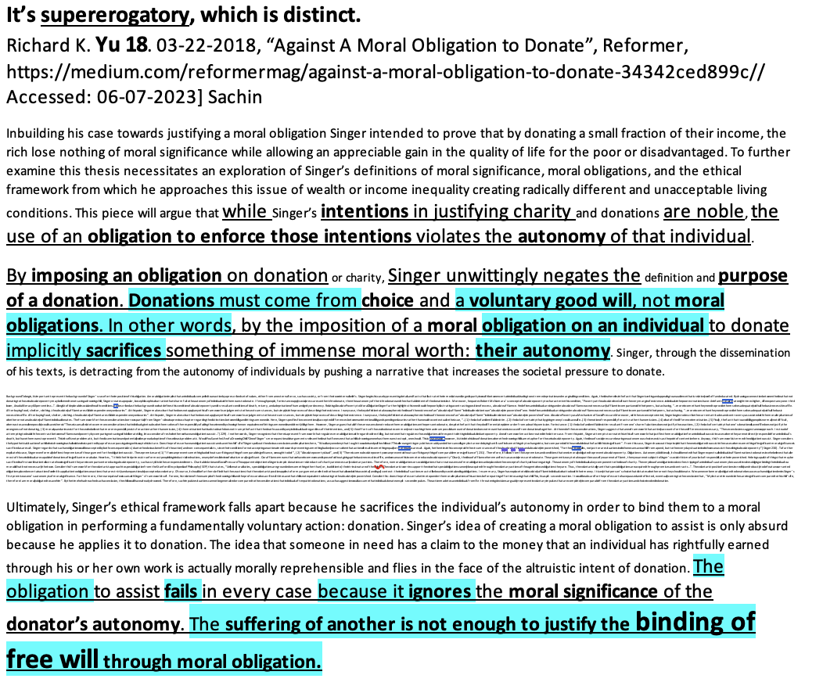

Why novices should learn this argument first
It is short, it is easy to explain to a lay judge, it requires no technical evidence, and it cannot be impact-turned. It also teaches the single most transferable skill in LD, which is attacking the modal claim in the resolution rather than the topic content.

6.2 Ought implies can: the feasibility press
If it cannot be done, it cannot be required. This is where the technical literature does framework work. Three cards, escalating.
CARD 6 | NEG, HUMAN BIOLOGY
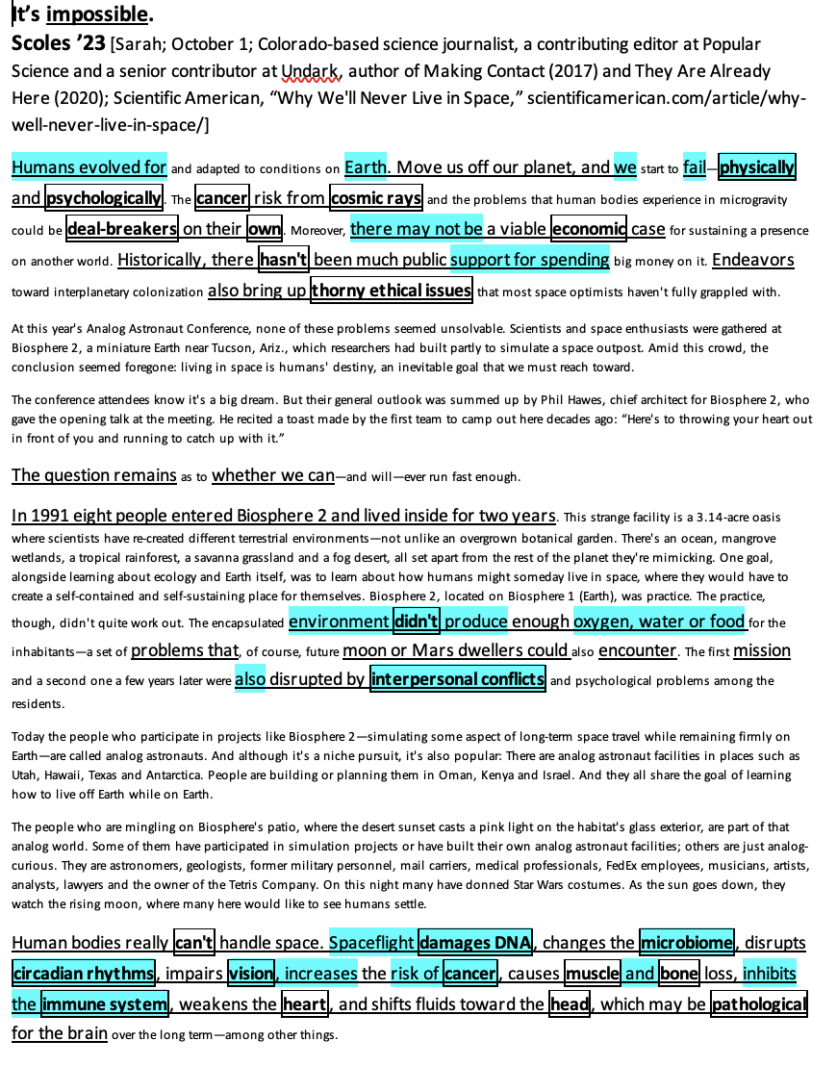
Scoles is useful because she is comprehensive and readable, which matters in front of a lay judge. The list is the argument: DNA damage, microbiome disruption, circadian disruption, vision impairment, cancer risk, muscle and bone loss, immune suppression, cardiac weakening, cephalad fluid shift. Add the partial-gravity blind spot, which is the sharpest version: we have human physiological data at zero gravity and at one gravity and essentially nothing in between. Nobody knows whether Mars at 0.38 g is enough to prevent any of this, or whether a fetus can develop in it.
CARD 7 | NEG, SYSTEMIC FEASIBILITY
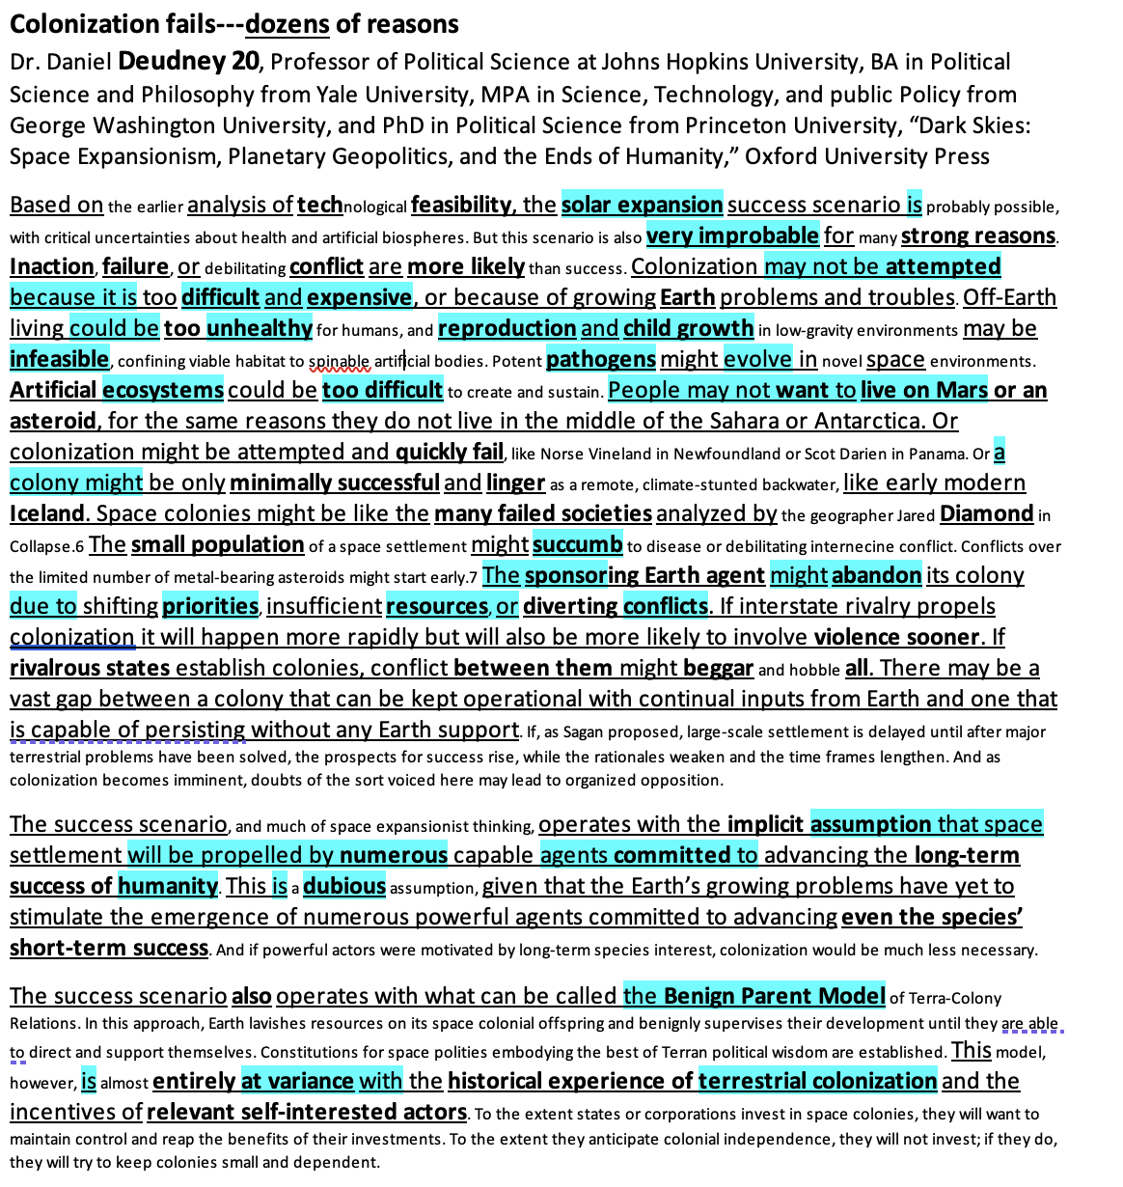
Deudney's version is broader and better for a framework argument, because he is not listing engineering obstacles. He is arguing that the success scenario depends on an implausible set of political assumptions: that numerous capable agents will commit to humanity's long-term good, that Earth will benignly parent its colonies, and that separate space ventures will reinforce rather than undercut each other. The last sentence is the extension you want.

The elegant version: the feasibility-necessity paradox
This is my favorite card in the entire file, because it is one argument that answers the Affirmative's uniqueness and its solvency simultaneously.
CARD 8 | NEG, FEASIBILITY-NECESSITY PARADOX
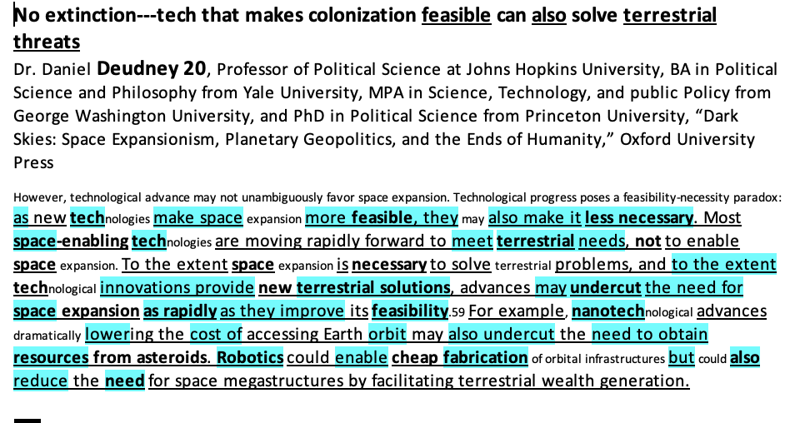
Explain it this way in a round: the technologies that would make space colonization achievable are the same technologies that would let us solve the terrestrial problems colonization is supposed to escape. Advanced robotics, cheap energy, closed-loop life support, radiation medicine. Every one of those is developed for Earth first. So the moment colonization becomes feasible is roughly the moment it becomes unnecessary, and an obligation that dissolves exactly when it becomes possible is not much of an obligation.

6.3 No duty-bearer
Follow the actor argument from Part 3 to its conclusion. An obligation with no agent to bear it is not an obligation. And when you name the actual agents, the moral framing wobbles.
CARD 9 | NEG, NO AGENT WILL ACT
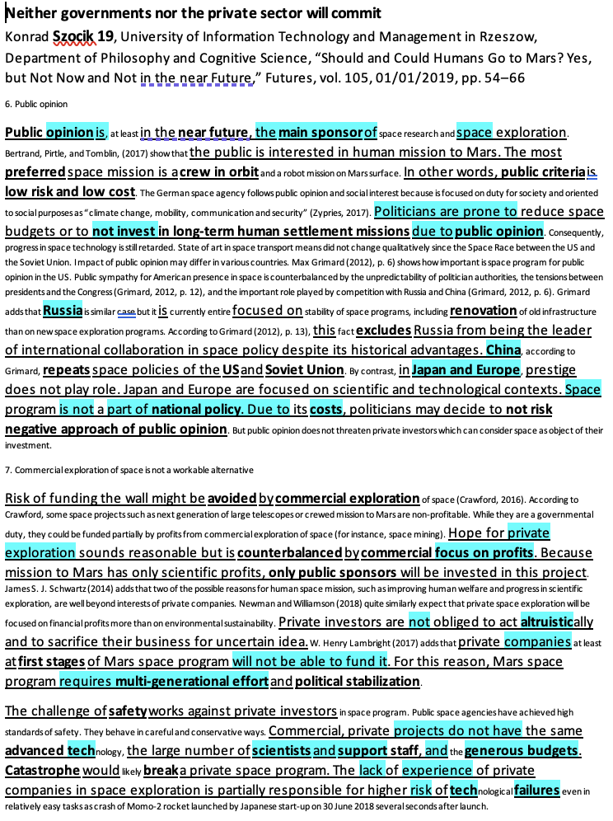
Structure the argument in three steps. Public agencies follow public opinion, and public opinion prefers low-risk, low-cost robotic missions. Private firms follow profit, and a self-sustaining backup colony has no business case, which is precisely why it is the piece nobody is building. Therefore the only entities capable of discharging the alleged duty are structurally disinclined to, and one of them, a corporation, cannot bear moral duties in the first place because its binding obligation runs to shareholders.

6.4 Opportunity cost: fix Earth first
The most intuitive Negative argument and the one lay judges find most persuasive. Every dollar and every engineer directed at Mars is a dollar and an engineer not directed at climate, poverty, or disease, where returns are measurable and immediate.
CARD 10 | NEG, TRADEOFF
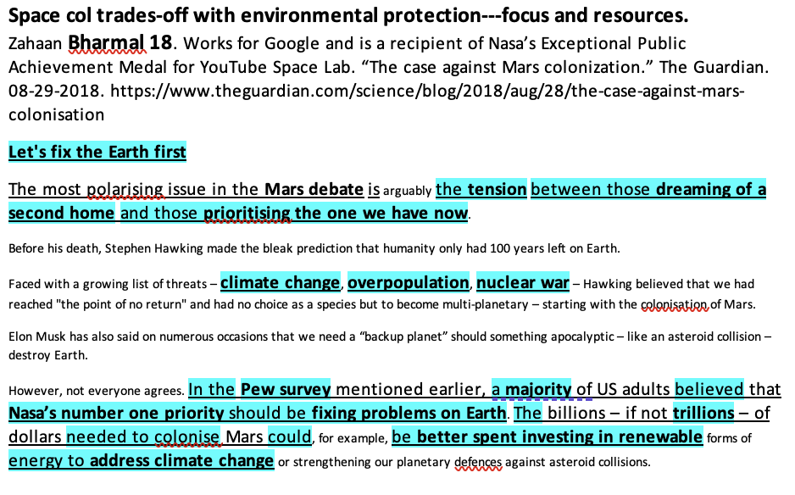
Pair this with the moral-hazard version, which is stronger philosophically: the promise of a second planet erodes the will to protect this one. Martin Rees calls the Planet B idea a dangerous delusion and says explicitly that coping with climate change, daunting as it is, is trivial compared to terraforming Mars.
Prepare for the AFF answer: even a climate-ravaged Earth is far more habitable than Mars, so nobody is actually going to treat Mars as an escape. That is a good answer. The Negative's rejoinder is that the moral hazard operates on political will, not on literal relocation plans, and political will is exactly what the AFF needs.

6.5 Risk inversion: colonization makes extinction more likely
The Deudney thesis in full, and the argument that most directly flips the Affirmative's case rather than merely answering it. Two sub-arguments have good evidence in the topic files.

(a) Militarization
Colonization requires permanent presence, permanent presence requires protection, and space is the ultimate high ground. The topic files carry a full militarization shell: colonization drives dual-use development, perceived dominance invites preemption, and a space conflict escalates because the states involved all hold nuclear weapons and losing satellite capability is exactly the kind of blinding that triggers lashout.
Deudney adds the sharpest version: the same technology that lets you deflect an asteroid away from Earth lets you aim one at it. Colonization does not just move humans, it hands humanity a planetary weapon.

(b) Disease
CARD 11 | NEG, BIOLOGICAL RISK
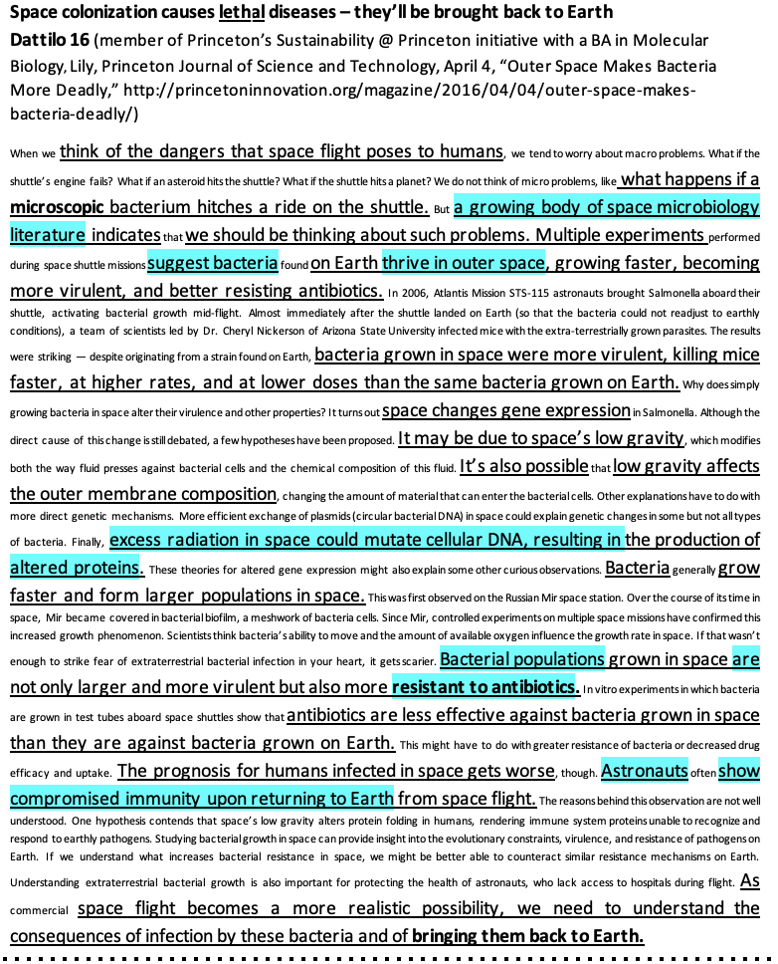
This is a good card for novices because the empirical claim is concrete and surprising, and the mechanism is easy to explain: microgravity changes bacterial gene expression, the resulting strains are more virulent and more antibiotic-resistant, and returning astronauts show compromised immunity. Then extend to the back-contamination scenario.

6.6 Suffering risk: the longtermist objection to longtermism
The most sophisticated position on the Negative, and the one that turns the Affirmative's own scale against it. Emile Torres argues in Futures that expansion generates a wide variety of distinct descendant civilizations with divergent traditions and values, that catastrophic conflict between them is the default outcome, and that the result is a Hobbesian predicament of permanent mutual fear. Their conclusion is the mirror image of Bostrom's: every second of delayed colonization could be desirable, and the best outcome is no colonization at all.
The second strand comes from suffering-focused ethics. Spreading Darwinian ecosystems to other worlds recreates predation, disease, starvation, and high infant mortality at astronomical scale. Brian Tomasik and the Center on Long-Term Risk develop this, and it is aimed precisely at the biotic-ethics position in Part 5.4.
Why this matters more than it looks: it is one of very few arguments that makes colonization wrong rather than merely premature or expensive. If the Affirmative's framework is maximizing expected wellbeing, this is a straight impact turn on their own terms.
Prepare for the answer: Cirkovic's published reply argues Torres oversimplifies, ignores postbiological evolution, and that arguments against cosmic diversity based on suffering risk edge toward arguments against diversity as such. The Space Col Good file has this blocked out.

6.7 The critical turn
Two kritiks have strong evidence in the topic files. Run one, not both. Their authors disagree with each other about which structure is foundational, and a good Affirmative will exploit that.

(a) Settler colonialism
The thesis is that colonization is not a metaphor. The resolution imports terra nullius, the conversion of land into property, and the logic of elimination into the cosmos, and calling it a moral imperative relaunders that logic as a duty.
CARD 12 | NEG, SETTLER COLONIALISM
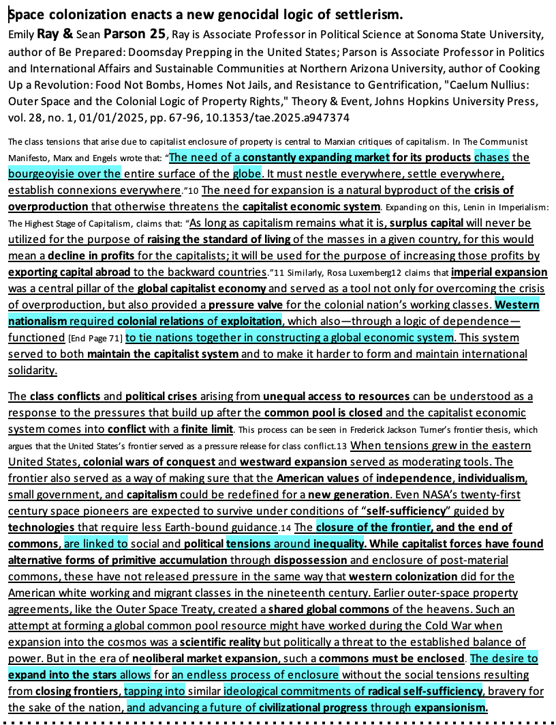
The key move to understand: the Affirmative's best-sounding defense, that Mars is genuinely uninhabited so the analogy fails, is on this reading the link itself. Declaring a place empty is the founding gesture of terra nullius. Ray and Parson also give you the Musk indentured-servitude detail, which lands hard in front of any judge.
The alternative: reject the resolution's settler framing and orient toward Indigenous and relational conceptions of space. Critically, the alternative is not “colonize justly.” Tuck and Yang's argument that decolonization is not a metaphor is the pre-built answer to the permutation.

(b) Capitalism and the spatial fix
Space colonization as capital's search for a new outside to absorb its crises, with “moral imperative” functioning as the ideology that makes an accumulation strategy look like destiny. Peter Dickens is the canonical link. The topic files also carry a strong governance link arguing that the framing treats space law as a neutral instrument when it is an interpretive battlefield, and that the current trajectory replaces res communis with neoliberal extractivism.
CARD 13 | NEG, PRIVATE COLONIZATION AND DEMOCRACY
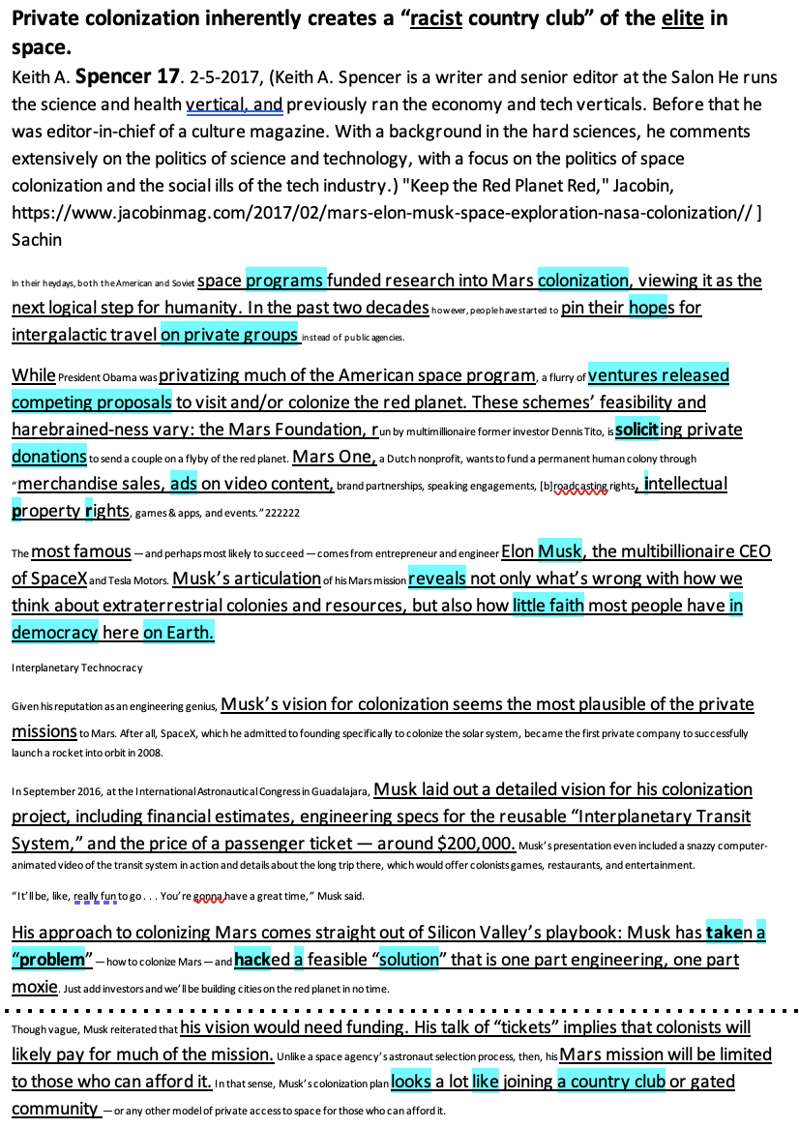

6.8 Framework menu for the Negative
Framework | How it negates | Best paired with
Supererogation / deontic categories | Concedes the good, denies the duty | Anything. This is the universal NEG tool.
Ought implies can | No obligation to do the impossible | Feasibility evidence (6.2)
Agent-relative deontology | Duties run to those we stand in relation to, not to possible future people | Opportunity cost (6.4)
Person-affecting views | Merely possible people have no claims on us | Answers the Bostrom card directly
Suffering-focused ethics | Preventing suffering is prior to creating value | S-risk (6.6)
Kritik framework / role of the ballot | Ontology and discourse precede policy evaluation | Either kritik (6.7)

Part 7. How Rounds Will Actually Play Out
Four matchups you should expect, with an honest read on who is favored in each.

Matchup 1. Utilitarian AFF versus utilitarian Neg
Both sides accept maximizing expected wellbeing. The debate collapses into a comparison of long-term risk profiles: does colonization reduce extinction risk more than it creates new risks?
AFF path: single point of failure, Cirkovic on multiplicity, timeframe pushed long.
NEG path: Deudney risk inversion, militarization, suffering risk, and the argument that terrestrial risk reduction is the better marginal buy.
Who is favored: roughly even, and it comes down to timeframe. Whoever controls whether we are evaluating this century or the next ten thousand years usually wins.

Matchup 2. Utilitarian AFF versus framework Neg
The NEG does not contest a single impact. They read the deontic categories, argue that extraordinary goods are supererogatory, and spend the rest of the round on why obligation requires more than magnitude.
AFF path: the precondition argument from Part 5.3, which is designed for exactly this. Alternatively, argue that supererogation is a category that presupposes a stable moral community and therefore cannot apply to the question of whether that community continues to exist.
NEG path: hold the line. Do not get drawn into impact debate. Every minute spent on radiation doses is a minute not spent on the argument you are winning.
Who is favored: the Neg, decisively, against an unprepared AFF. This is the single most important matchup to drill.

Matchup 3. Affirmative versus kritik
The NEG argues the resolution's framing is the harm. The AFF has to decide early whether to engage the framework or the link.
AFF path A, framework: argue that the ballot should evaluate the truth of the resolution, that the topic literature is about a real question, and that requiring debaters to defend the ontology of the topic makes the AFF burden unmeetable.
AFF path B, substance: extinction outweighs, and the alternative cannot resolve the material risk. Be careful: the kritik's framework argument is that the extinction scenario is itself produced by the extractive orientation, so the impact is a link, not an outweigh.
AFF path C, permutation: do the resolution through a decolonial or common-heritage model. Works better against the capitalism kritik than against settler colonialism, and could be justified depending on the framework interp the NEG opts for.
Who is favored: depends heavily on the judge and the circuit. At novice and middle-school levels this is less common, but you should know the shape of it.

Matchup 4. Presumption and permissibility
Worth flagging even though it is more advanced. Because the resolution asserts a strong modal claim, a Negative can argue that in the absence of a conclusive reason to think colonization is required, the default is that it is not. This is not skepticism about morality generally, it is a narrower point about burden.
The Affirmative pre-empt: argue that presumption on this topic should flow AFF because the status quo of doing nothing has a moral cost that accumulates, per Bostrom, and inaction is itself a choice with consequences. That is a real argument, not a trick.

Part 8. Starter Case Skeletons
These are outlines, not cases. Do not read them as written. Use them to see the shape of a complete argument before you fill it with your own evidence and your own words.

Affirmative skeleton
Framework: The standard is maximizing expected wellbeing, justified by the precondition argument. Existence of moral agents is the condition under which any other moral standard can apply, so a framework that cannot account for the survival of agency is self-undermining.
Pre-empt 1: Supererogation. Answer in the 1AC. Explain why a duty grounded in the preconditions of morality is not the same kind of claim as a duty of beneficence, and therefore is not subject to latitude.
Pre-empt 2: Ought doesn’t imply can. Define the imperative as a duty to pursue, not a duty to complete.
Contention 1: Correlated risk. Every human being occupies one biosphere. Asteroid impact, supervolcanism, nuclear exchange, and engineered pandemic are all single-planet-terminal. [Reuter, Ord]
Contention 2: Earth-based measures cannot solve. Refuges, seed vaults, and bunkers share the system they are meant to survive. Multiplicity is structurally more robust than uniqueness. [Cirkovic]
Contention 3: The moral weight of the foregone future. Delay is not neutral. It has a cost measured in worthwhile lives that never exist. [Bostrom-adjacent]

Negative skeleton
Framework: The resolution is a claim about obligation, so the Negative burden is only to defeat the obligation. Establish the four deontic categories in the first ninety seconds and make the judge hold the AFF to the strongest one.
Contention 1: The supererogation press. Civilization-scale aspirational goods are the paradigm of the good-but-optional. Even a fully successful AFF establishes at most that colonization is admirable. [SEP on supererogation]
Contention 2: Ought implies can. Radiation, partial gravity, reproduction, and closed-loop life support are unsolved, and no self-sustaining artificial biosphere has ever worked. [Scoles, Deudney, Biosphere 2]
Contention 3: No duty-bearer. Public agencies follow public opinion toward low-cost robotic missions; private firms follow profit and there is no business case for the one piece that matters. [Szocik]
Contention 4, optional: Risk inversion or opportunity cost, depending on what the AFF reads. Pick one. Do not read four contentions and a kritik.

Discipline note for both sides
The most common structural error I see on framework-heavy topics is a case that tries to win five ways. It reads a framework, four contentions, and three pre-empts, and covers none of them well enough to survive a good rebuttal. On this resolution, two well-defended arguments beat five gestured-at ones every single time, because the round will be decided at the level of whether the obligation exists, and that is one question.

Part 9. Research Assignments
What is not already in the files, in the order I would cut it.

Priority 1: the obligation literature
Green, Brian Patrick. “An obligation to colonize outer space.” Futures 110 (2019). The single highest-value uncut article for the Affirmative.
Munevar, Gonzalo. In the same 2019 Futures special issue on Mars ethics. Parallel argument, useful as a second source.
Mautner, Michael. Work on biotic and panbiotic ethics. Search “biotic ethics” and “directed panspermia.”
Stanford Encyclopedia of Philosophy, entry on “Supererogation” (David Heyd). Cut the obligatory / permissible / supererogatory / forbidden taxonomy and the “extremely beneficial consequences” line. Both sides need this.

Priority 2: the suffering-risk exchange
Torres, Phil (Emile). “Space colonization and suffering risks: Reassessing the maxipok rule.” Futures 100 (2018), pp. 74-85.
Cirkovic, Milan. “Space colonization remains the only long-term option for humanity: A reply to Torres.” Futures 105 (2019). Free preprint on PhilSci-Archive.
Kovic, Marko. “Risks of space colonization.” Futures 126 (2021). Already partially in the files; get the full text.

Priority 3: hard technical numbers
Lay judges respond to specific figures. Get these with citations so you can say them confidently.
Mars mission radiation dose and how it compares to career exposure limits. Sources: Zeitlin et al., Science, 2013 (transit dose); Hassler et al., Science (surface dose); NASA and ESA career limits.
Bone mineral density loss per month in microgravity. NASA and the Canadian Space Agency both publish this.
Jakosky and Edwards, Nature Astronomy, 2018, the NASA-sponsored study finding Mars lacks enough accessible carbon dioxide to terraform with present technology.
Biosphere 2, 1991 to 1993. Oxygen decline, species loss, crop failure, crew weight loss, and factional split. The best single anecdote on the Negative.

Priority 4: the critical literature
Smiles, Deondre. “The Settler Logics of (Outer) Space.” Society and Space, 2020. Free online.
Trevino, Natalie. “The Cosmos Is Not Finished” and related work on the coloniality of space exploration.
Tuck, Eve and K. Wayne Yang. “Decolonization Is Not a Metaphor.” 2012. The permutation answer.
Dickens, Peter. “The Humanization of the Cosmos: To What End?” Monthly Review, 2010. The capitalism link.
Wolfe, Patrick. “Settler Colonialism and the Elimination of the Native.” 2006. The structure-not-event claim.

Priority 5: primary documents
Read these yourself rather than through a card. They are short and both sides quote them.
The Outer Space Treaty (1967), Articles I and II. Available through UNOOSA.
The Artemis Accords, especially Section 10 on space resources, and the 2015 US Commercial Space Launch Competitiveness Act. These are the documents the extractivism arguments are about.
The Moon Agreement (1979) and its Common Heritage of Mankind principle, which almost no spacefaring nation signed. Useful for the equity arguments.

Where the existing files already have you covered
You do not need to re-cut: existential risk framing (Reuter, Globus, Ord secondhand), colonization feasibility defense (Levchenko, Szocik, Morton, Scoles, Deudney), the full militarization and disease shells with impact extensions, the capitalism kritik with governance and property links, the settler-colonialism impacts, and a large block file answering aliens, animals, asteroid deflection, debris, disease, resource wars, light pollution, s-risks, space terror, war, and so much more.
That block file is the most underused asset Podium has on this topic. It is organized by argument and it is deep.

Appendix. Source List
Links to the primary literature discussed in this brief. Journal articles behind paywalls are noted where a free preprint exists.

Affirmative and pro-colonization
Bostrom, “Astronomical Waste” (2003)
Green, “An obligation to colonize outer space,” Futures (2019)
Cirkovic, reply to Torres, Futures (2019) [free preprint]
Reuter, “Why The Human Race Must Become A Multiplanetary Species,” WEF (2021)
Globus, “Not so dark skies,” The Space Review (2020)
Weatherford on the moral imperative of space travel, Philosophy Now

Negative and critical
Torres, “Space colonization and suffering risks,” Futures (2018)
Kovic, “Risks of space colonization,” Futures (2021)
Deudney, Dark Skies (Oxford, 2020) [publisher page]
Scoles, “Why We'll Never Live in Space,” Scientific American (2023)
Bharmal, “The case against Mars colonisation,” The Guardian (2018)
Spencer, “Keep the Red Planet Red,” Jacobin (2017)
Smiles, “The Settler Logics of (Outer) Space,” Society and Space (2020)
Dickens, “The Humanization of the Cosmos: To What End?” Monthly Review (2010)
Bhargavi, “Not 'Manifest' but an 'Inclusive' Destiny,” E-International Relations (2025)
Viterbi Conversations in Ethics, “Space Colonization and Why Humanity is Better Off Not Pursuing It”

Framework and primary documents
Stanford Encyclopedia of Philosophy, “Supererogation”
Internet Encyclopedia of Philosophy, Kant's moral philosophy
The Outer Space Treaty (1967), full text via UNOOSA
UNOOSA space law treaties index
Britannica ProCon, space colonization debate overview
Blue Marble Space Institute, “Ethics of Space Colonization”

Questions?

Questions on any of this
Reach out at sachin@podiumdebate.com!
If your student is working through this topic and wants to talk through a case, that is exactly the kind of conversation our cohorts are built around.

